Detector-Plane Imaging (DPI):

A Measurement-Plane Framework

Abstract
Detector-Plane Imaging (DPI) establishes that interference is encoded in a pre-detection coherence imprint and that detector-plane processing determines whether this structure is preserved or irreversibly lost. Integrating the Imprint Hypothesis with the Quantum Measurement Stack (QMS), this framework treats quantum measurement as a hardware-defined selection process.

1. Introduction
Quantum interference experiments are often interpreted through wave–particle duality, leading to ambiguity about when and how interference arises. DPI resolves this by separating:
- Pre-detection coherence (imprint domain)
- Post-detection measurement outcomes
Particles remain primary excitations of quantum fields, while wave-like behavior emerges as a contextual imprint of propagation.

2. Causality: Quantum Measurement Stack (QMS)
Quantum processes follow a strict causal order:
Field excitation → Imprint propagation → Detector plane → Readout → Analysis
The detector plane defines the measurement boundary where:
- Correlations may be preserved or discarded
- Information loss becomes irreversible
Once lost, correlations cannot be recovered by downstream processing.

Figure 1: Quantum Measurement Stack (QMS). The detector plane defines the measurement boundary where irreversible information loss occurs.

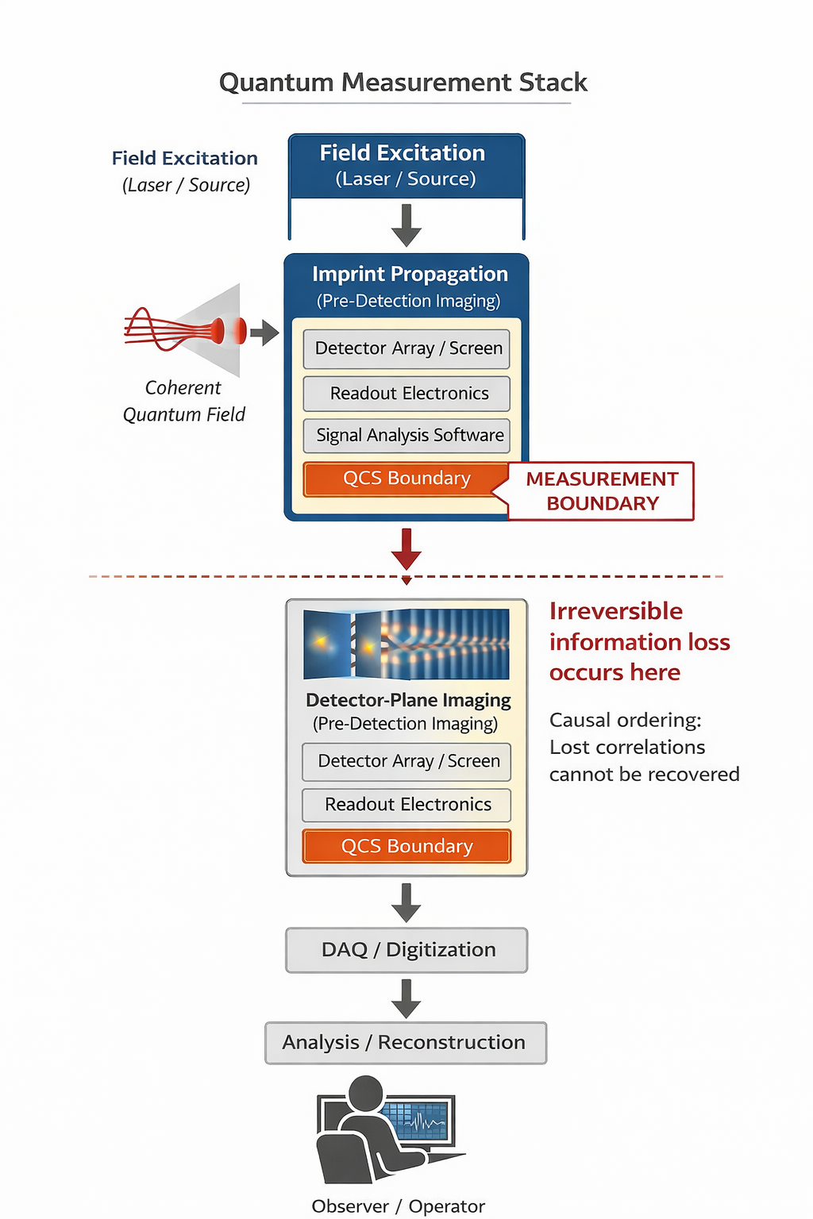

3. Mechanism: Detector-Plane Selection (DPI)
A single coherence imprint arrives at the detector as a continuous, phase-encoded structure. The detector determines whether this structure becomes observable.
Two regimes emerge:

Intensity-Only Detection
- Measures amplitude only
- Phase correlations discarded
- Output: No stable interference

Correlation-Preserving Detection
- Retains phase correlations
- Preserves coherence structure
- Output: High-contrast interference
Thus, interference is not created at detection but conditionally revealed.

Figure 2: A single coherence imprint leads to different outcomes depending on detector-plane coherence preservation.

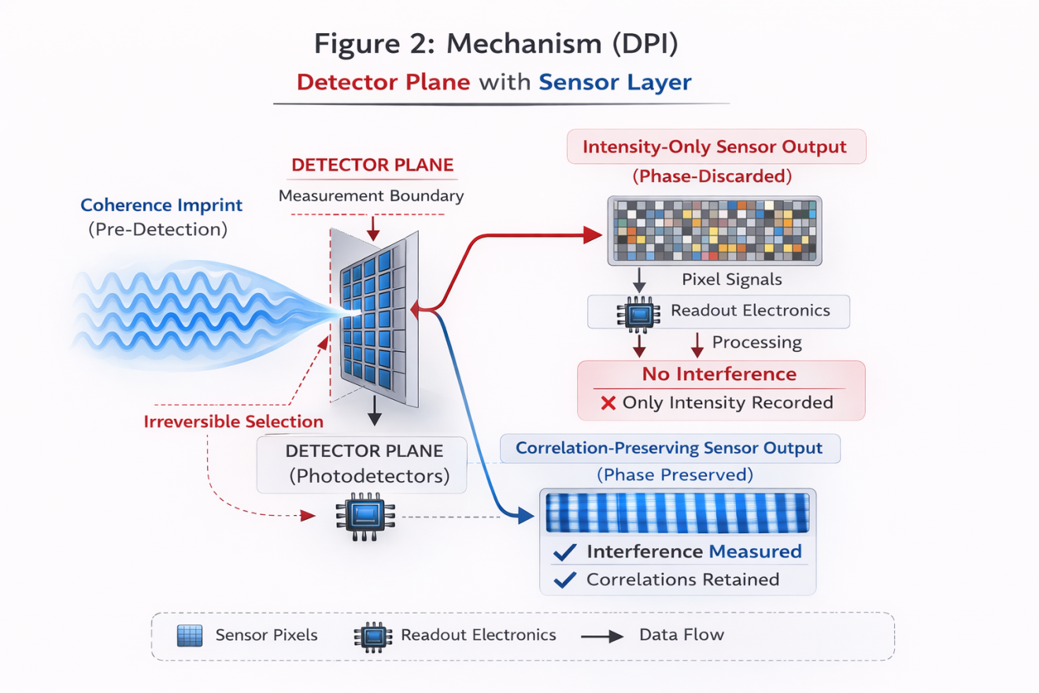

4. Validation: QMCTB-01 Benchmark
The QMCTB-01 benchmark isolates detector-plane behavior by keeping all other conditions identical:
- Excitation
- Propagation
- Photon statistics
Only detector architecture changes.
Results:
- Intensity-only detection → no interference
- Correlation-preserving detection → stable interference
This demonstrates that:
Interference visibility is determined by detector-plane coherence preservation, not photon accumulation.

Figure 3: Identical input conditions produce different observed outcomes due solely to detector architecture. Interference visibility is determined by detector-plane processing.

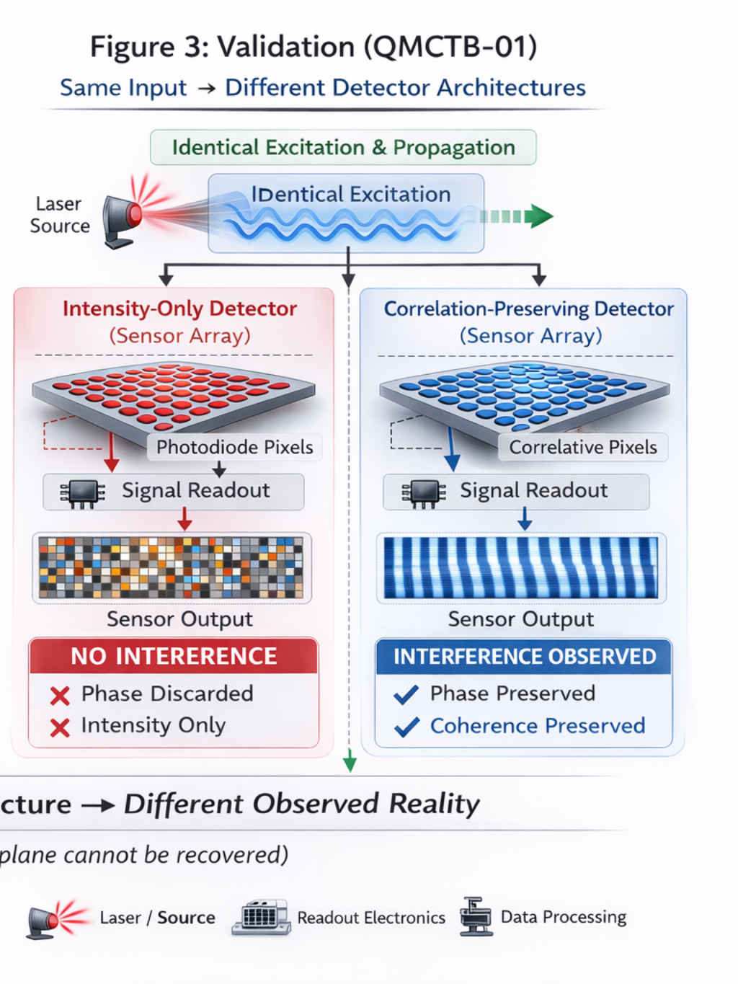

5. Key Insight
Interference is encoded prior to detection; the detector determines its observability.
This removes ambiguity in wave–particle duality by distinguishing:
- Physical reality: particle-based field excitations
- Measurement outcome: detector-dependent imprint selection

6. Conclusion
DPI reframes quantum measurement as a detector-defined process. The coherence imprint exists prior to detection, and irreversible information loss at the detector plane determines observable outcomes. This framework is fully compatible with quantum field theory and provides a testable, hardware-grounded understanding of quantum measurement.

